ViCap: A Vietnamese Image Dataset for Assistive Vision
for People with Visual Impairments
Lan Anh Nguyen Thi¹, Hải Minh Nguyễn²
Abstract
People with visual impairments in Vietnam face significant challenges in accessing visual information from printed text, public signs, transportation systems, and everyday environments. Despite rapid advances in vision–language models, research on Vietnamese assistive vision remains limited by the lack of publicly available datasets that reflect authentic local scenarios. This paper presents ViCap, a manually curated Vietnamese image dataset designed for assistive vision research. ViCap contains approximately 22,222 images collected from diverse real-world environments, including streets, buses, metro stations, restaurants, educational materials, and public-service facilities in Ho Chi Minh City and Ha Noi. Each image is annotated with rich multimodal information, including scene categories, object labels, OCR text, image captions, navigation-oriented descriptions, obstacle warnings, safety guidance, location cues, and visual question–answer pairs. The annotations are designed to support practical assistive tasks such as reading public signs, understanding surrounding environments, recognizing obstacles, and answering scene-related questions. Preliminary baseline experiments using representative vision–language models demonstrate the applicability of ViCap for image captioning and visual question answering. The proposed dataset provides a valuable benchmark for developing and evaluating Vietnamese vision–language systems that improve accessibility for people with visual impairments.
Keywords: Vietnamese image dataset, assistive vision, visual impairment, image captioning, visual question answering, optical character recognition (OCR)
1. Introduction
Vision impairment affects access to education, transportation, public services, and everyday information. The World Health Organization (2019) emphasizes that vision impairment is not only a clinical issue but also a challenge for participation and independent living. In Vietnam, many practical visual tasks involve local language and context: reading a bus route display, identifying a metro entrance, interpreting a restaurant menu, understanding a textbook illustration, or recognizing an obstacle on a crowded sidewalk. Generic image-captioning datasets rarely represent this combination of Vietnamese scene text, dense urban environments, and assistance-oriented language.
Existing assistive datasets have demonstrated the importance of collecting data from real user needs. In this setting, photographs may be poorly framed, conversationally queried, and sometimes unanswerable. VizWiz-Captions provides captions for images taken by blind photographers (Gurari et al., 2020). This resource established an important user-centered direction, but it is primarily an English-language dataset and does not capture Vietnamese signs, transportation conventions, food terminology, or educational materials.
Vietnamese multimodal resources remain comparatively limited. UIT-ViIC contains Vietnamese captions for a sports-oriented subset of MS COCO (Lam et al., 2020), KTVIC focuses on daily-life image captioning (Pham et al., 2024), and ViVQA supports Vietnamese visual question answering (Tran et al., 2021). These datasets are valuable benchmarks, yet none is specifically organized around the combined accessibility needs of reading, orientation, obstacle awareness, and contextual question answering in Vietnamese public environments.
This paper presents ViCap, a Vietnamese assistive vision dataset constructed through model-assisted annotation and human verification. The project has three main contributions. First, it collects 22,222 images from locally relevant domains, including streets, buses, metro stations, restaurants, indoor public spaces, textbooks, and learning materials. Second, it defines a multi-task annotation schema containing concise and detailed descriptions, scene and object labels, OCR text, navigation information, obstacle and safety guidance, and visual question-answer pairs. Third, it implements a model-assisted, human-in-the-loop workflow in which vision-language models generate structured drafts and human reviewers inspect the corresponding image, edit each field, and explicitly approve the corrected record.
The objective of ViCap is not to treat generated text as ground truth automatically. Instead, model output is used as a first draft to reduce repetitive annotation effort, while human verification remains the quality-control stage. The resulting resource is intended to support future Vietnamese image captioning, text-aware visual question answering, scene understanding, and speech-based assistive systems.
2. Literature Review
2.1. Assistive Image Captioning and Visual Question Answering
Early image-captioning benchmarks commonly used photographs captured by sighted photographers and captions written for general description. Assistive use differs because the image itself may be poorly framed, blurry, text-heavy, or centered on a specific question. User-centered assistive benchmarks therefore prioritize the photographer's information needs, while VizWiz-Captions focuses on descriptions of images taken by blind photographers (Gurari et al., 2020). This direction motivates datasets that prioritize user intent rather than only generic visual salience.
Reading text embedded in scenes is another central requirement. Text-aware visual question answering requires recognizing and reasoning over words appearing in images. This capability is directly relevant to Vietnamese public signs, route numbers, ticket-machine instructions, menus, prices, and textbook content. A useful assistive dataset therefore needs both a transcription-oriented field and natural-language fields that interpret the text in relation to surrounding objects and user goals.
2.2. Vietnamese Vision-Language Resources
UIT-ViIC was an early benchmark for Vietnamese image captioning, with 3,850 images and 19,250 manually written captions (Lam et al., 2020). KTVIC expanded coverage toward daily-life activities with 4,327 images and 21,635 captions (Pham et al., 2024). ViVQA introduced Vietnamese question answering over images and provided a foundation for multimodal question answering in the language (Tran et al., 2021). Together, these resources show increasing interest in Vietnamese multimodal processing.
However, existing Vietnamese datasets generally target one main task, such as captioning or VQA. Assistive use often requires several outputs for the same image. A short caption may be appropriate for rapid orientation, whereas a detailed description is useful for studying a textbook page. OCR text may answer a route or price question, while an obstacle warning may require conservative language and spatial information. ViCap addresses this gap through a unified, domain-sensitive schema.
2.3. Vision-Language Models and Human Verification
Recent vision-language models can follow instructions and generate structured descriptions from images. BLIP-2 demonstrated that frozen visual encoders and large language models can be connected efficiently for image-to-text generation (Li et al., 2023a). More recent model families, including Gemini 2.5 and Qwen2.5-VL, further support multimodal reasoning, document understanding, OCR, and structured extraction (Bai et al., 2025; Comanici et al., 2025).
These capabilities make model-assisted annotation practical, but they do not remove the need for verification. Large vision-language models can hallucinate objects that are absent from the image (Li et al., 2023b), and generative outputs may also misread text, confuse left and right, or express uncertain safety judgments too confidently. For this reason, ViCap uses models to draft labels and requires human reviewers to compare every editable field against the image. This design is also consistent with dataset-documentation principles that call for transparent reporting of collection, annotation, intended use, and limitations (Gebru et al., 2021).
3. Methodology
3.1. Dataset Scope and Collection
The dataset is organized around situations in which visual information can affect access, orientation, or safety for people with visual impairments in Vietnam. Images were obtained through two complementary collection channels. First, the authors captured photographs with mobile phones at streets, bus stops, metro stations, restaurants, indoor public spaces, and other locations in Ho Chi Minh City. Second, additional images were collected selectively from publicly accessible Internet sources, including social-media pages, to extend domain and geographic coverage. Source links or identifiers and access dates should be retained when available, and inclusion in the research corpus does not automatically imply permission for public redistribution. The images cover seven broad domain groups:
- Urban streets and sidewalks, including crossings, intersections, construction zones, parked vehicles, poles, tree roots, and other obstacles.
- Bus environments, including stops, approaching buses, route displays, interiors, curbs, and boarding areas.
- Metro environments, including entrances, concourses, ticket machines, ticket gates, platforms, tactile paving, line maps, and train interiors.
- Restaurants and food-service settings, including dishes, menus, prices, utensils, table layouts, entrances, and nearby obstacles.
- Indoor public environments, including room type, object placement, signs, passageways, stairs, and service facilities.
- Textbooks and educational materials containing illustrations, diagrams, printed Vietnamese text, and learning content.
- Other public-service and daily-life scenes relevant to reading or independent access.
At the time of writing, the dataset inventory contains 22,222 image records. The collection includes separate subsets for buses in Ho Chi Minh City and Hanoi, streets in Ho Chi Minh City, metro environments, restaurants, indoor environments, and books or educational materials. Annotation and human verification remain ongoing, so the record inventory should be distinguished from the number of fully reviewed records.
3.2. Preprocessing and Duplicate Control
The labeling notebooks accept common image formats and normalize unsupported or inconvenient formats to JPEG. Before an API request, large images are converted to RGB and resized so that the longest side does not exceed 1,024 pixels. Images are encoded as JPEG with quality 85 in memory before being sent to the API. This reduces request size while retaining scene text and spatial context at a practical resolution.
The transport workflow includes exact-duplicate detection based on an MD5 fingerprint of RGB pixel content. When duplicate content is found, the repeated file and its corresponding spreadsheet row can be removed. This mechanism detects exact pixel duplicates; perceptual near-duplicate detection remains future work. Files with invalid responses are retried, and intermediate results are checkpointed after every five successfully processed images. Existing filenames are loaded before each run so completed images are skipped.
3.3. Domain-Specific Annotation Schema
All domains share a common descriptive core, while specialized fields capture the user's likely information needs. Table 1 summarizes the schema found in the supplied notebooks and exports.
Domain | Shared description fields | Specialized fields
Street | scene type, short caption, detailed caption, objects, visible text | navigation caption; obstacle, safety, and location answers
Bus/metro | scene type, short caption, detailed caption, objects, visible text | obstacle, safety, and route/information answers
Restaurant | scene type, short caption, detailed caption, OCR text | food name and components; dish, utensil, spatial safety, price/menu answers; safety flags
Indoor | scene and room type, short caption, detailed caption, OCR text | object positions, three VQA answers, automatic flags, notes
Educational | page image, short caption, detailed caption | type, collection, title, grade, subject, author, publisher, volume
Table 1
Domain-specific annotation schema
Short captions provide an immediate summary. Detailed captions describe objects, relative positions, colors, text, and environmental context. Navigation captions prioritize what is ahead, to the left or right, and whether the path appears blocked. OCR fields preserve visible text without requiring it to form a fluent sentence. VQA fields are domain-specific: street and transit data ask about obstacles, safety, location, routes, and signs; restaurant data ask about dishes, ingredients, utensils, seating safety, and menu prices. The educational subset is maintained in a separate JSONL schema that combines page-level captions with bibliographic and curriculum metadata rather than the shared safety-oriented fields.
Safety-related outputs are phrased as observations and cautions rather than guaranteed navigation instructions. For example, a record may state that motorcycles block a sidewalk or that a yellow tactile path leads toward a ticket machine. Such annotations are intended as supervision for assistive research, not as certified mobility guidance.
3.4. Model-Assisted Label Generation
The first-stage notebooks use instruction prompts to request a strict JSON object for each image. The transport pipeline uses Gemini 2.5 Flash, while the indoor and restaurant pipelines use a 27-billion-parameter Qwen-family model served through the FIT-HCMUS OpenAI-compatible API. Temperature is set to 0.1 to reduce unnecessary variation. The response parser removes optional Markdown fences, validates the JSON object, maps nested outputs to spreadsheet columns, and records errors for retry.
The prompt is specialized by domain. In transportation scenes, it emphasizes route information, obstacles, tactile paving, platform boundaries, and movement safety. In restaurants, it emphasizes food identity, components, menu text, prices, utensil locations, and hazards such as hot food or fragile objects. In indoor scenes, it records room type, object positions, OCR text, captions, VQA answers, and automatic warning flags. The result is stored in Excel during annotation and can be exported to JSON Lines for downstream training.
Figure 1 presents representative annotation records from the smaller indoor and metro domains. The indoor example combines a mixed-room scene label with short and detailed descriptions of the living area, dining table, staircase, kitchen, and television. The metro example records the train-interior scene, a concise caption, a longer spatial description, object labels, and a VQA response concerning the clear central aisle and available hand straps. These examples illustrate how the schema changes with domain while retaining a common descriptive core.
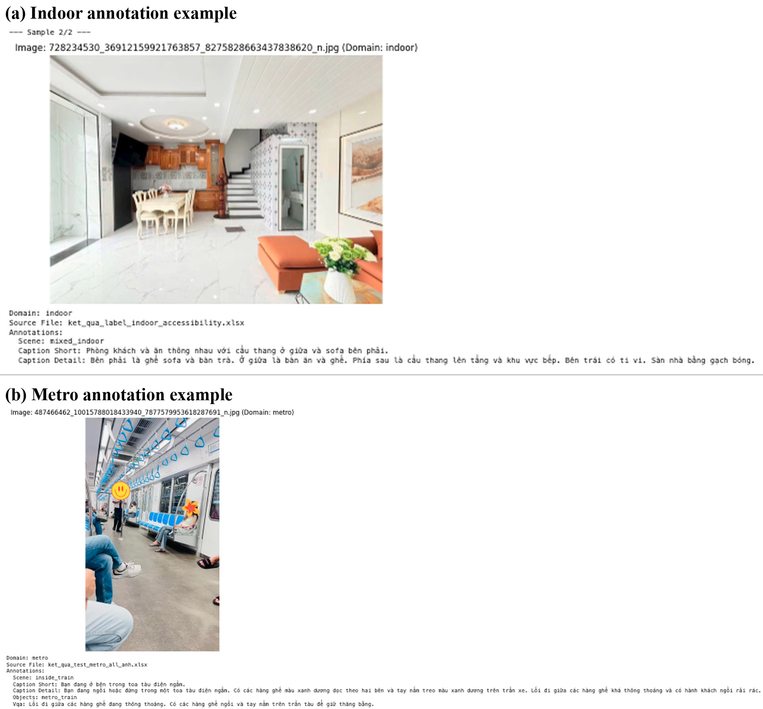
Figure 1
Representative model-assisted annotation records from two smaller ViCap domains: (a) an indoor mixed-room scene and (b) a metro-train interior.
3.5. Human-in-the-Loop Verification
Model-generated records are reviewed through a custom web interface connected to a tabular backend. The interface displays the source image beside editable fields. Reviewers can enlarge or reduce the image, jump to a row, move backward or forward, edit any generated value, and use an 'OK and next' action to save the corrected record. Keyboard shortcuts support repeated review at scale.
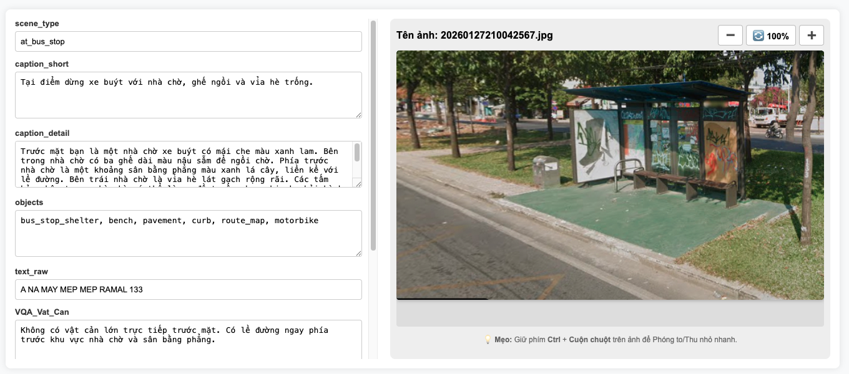
Figure 2
Human verification of a bus-stop record. The reviewer compares the image with editable fields for scene type, captions, objects, OCR text, and task-specific answers.
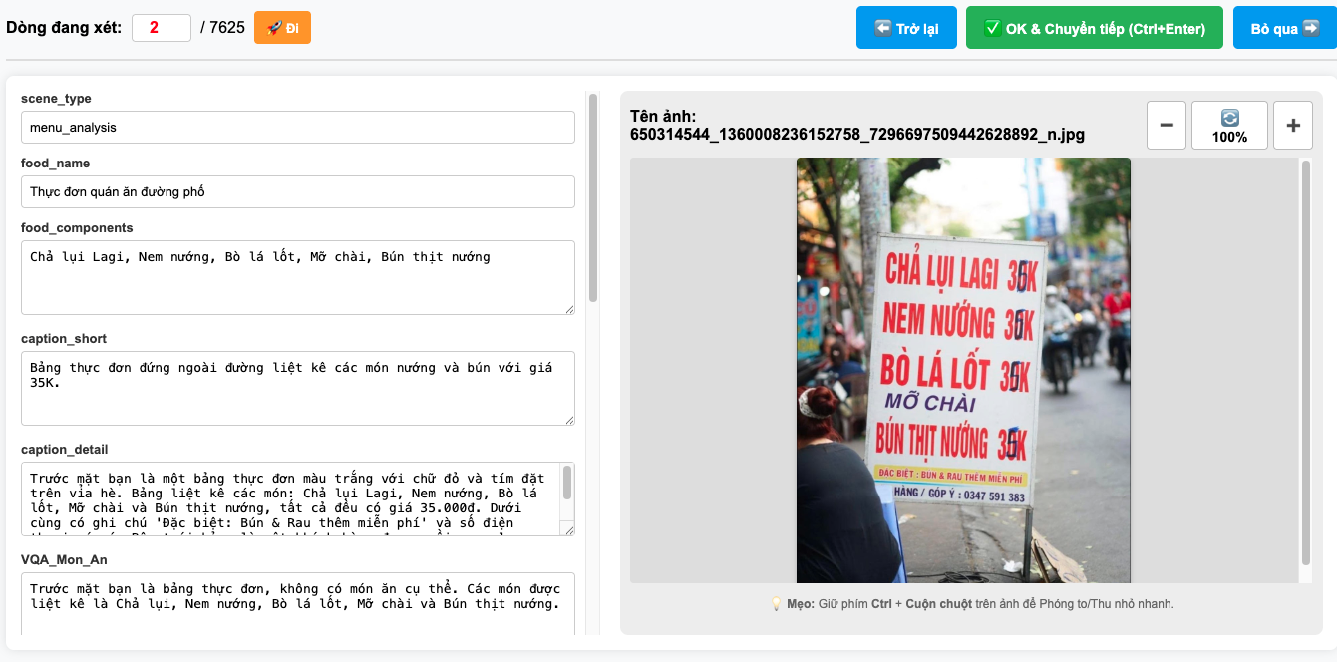
Figure 3
Restaurant-domain verification interface with specialized labels for menu analysis, food content, prices, spatial information, and safety.
The reviewer is instructed to correct four common error types: (a) unsupported objects or actions, (b) incorrect OCR strings, (c) incorrect spatial relations or navigation cues, and (d) unsafe or overly certain guidance. Empty fields are retained when the requested information is not visible. The review interface therefore supports both correction and abstention rather than forcing an answer.
3.6. Quality Assurance and Data Governance
Quality control is performed at three levels. First, automated checks validate filename uniqueness, JSON structure, expected columns, and checkpoint persistence. Second, field-level inspection identifies missing outputs and unusually short or long descriptions. Third, human review verifies semantic consistency against the source image. The current workflow records the corrected value but does not yet preserve the original model output and edit history in separate fields; future versions should retain both to measure correction rates and reviewer agreement.
Before public release, images and annotations require a rights and privacy audit. Street and restaurant images may contain faces, vehicle license plates, telephone numbers, or other incidental identifiers. Textbook pages may be protected by copyright. The planned release procedure therefore includes identifying the legal basis for distribution, redacting sensitive content when necessary, documenting licenses and sources, and excluding records that cannot be shared responsibly. A dataset card should describe intended use, prohibited use, collection bias, and known limitations (Gebru et al., 2021).
4. Results
4.1. Dataset Composition
The current ViCap inventory contains 22,222 records across seven subsets. The final statistics notebook loads 17,198 records from six Excel-based domains, while the separately maintained book inventory contributes 5,024 records. Table 2 reports the combined distribution.
Subset | Records | Share
Bus HCM | 2,123 | 9.6%
BusHN | 1,283 | 5.8%
Street_HCM | 5,297 | 23.8%
metro | 549 | 2.5%
restaurant | 7,624 | 34.3%
indoor | 322 | 1.4%
book | 5,024 | 22.6%
Total | 22,222 | 100.0%
Table 2
Updated composition of the ViCap collection
Restaurant scenes form the largest subset with 7,624 records (34.3%), followed by Street HCM with 5,297 records (23.8%) and books or educational materials with 5,024 records (22.6%). The three public-transport subsets contain 3,955 records in total: 2,123 Bus HCM images, 1,283 Bus Hanoi images, and 549 metro images. Indoor environments currently contain 322 records and represent the smallest subset.
ViCap is intentionally multi-domain rather than class-balanced. The restaurant, Street HCM, and book subsets together contain 17,945 records, accounting for 80.8% of the current inventory, whereas the metro and indoor subsets contain 871 records, or 3.9%. This distribution reflects current collection priorities, source availability, and the emphasis on frequently encountered educational and daily-life contexts. The smaller metro and indoor subsets represent domain groups that are still being expanded. Consequently, future evaluation should report per-domain results and should not assume that the current inventory provides a balanced estimate of all assistive scenarios.
4.2. Textbook and Educational Subset
The book domain is maintained separately from the six Excel exports used by the final cross-domain statistics notebook. The complete project inventory currently contains 5,024 book and educational images. A separate JSONL export available for detailed analysis contains 1,237 textbook pages, representing the portion for which structured book metadata and caption statistics were reported. Every record in this analyzed export contains an identifier, image reference, short caption, detailed caption, type, collection, title, grade, subject, author, and publisher. The optional volume field is available for 431 pages and missing for 806 pages.
Subject | Pages | Share
Natural and Social Sciences | 407 | 32.9%
Vietnamese | 305 | 24.7%
Mathematics | 302 | 24.4%
Ethics | 223 | 18.0%
Total | 1,237 | 100.0%
Table 3
Subject distribution in the analyzed textbook JSONL export
The analyzed textbook pages cover four school subjects, with Natural and Social Sciences forming the largest group. Short captions contain an average of 29.7 words, whereas detailed captions contain an average of 272.0 words. The substantially longer detailed descriptions reflect the need to explain diagrams, illustrations, page structure, and instructional context rather than only identify salient objects. Because this analysis covers 1,237 of the 5,024 book images, the subject and caption-length distributions should be treated as statistics for the current structured export rather than the final full book subset.
4.3. Spatial Relation Distribution
A record-level lexical analysis was conducted on the 17,198 records loaded from the six non-book Excel exports. The separately maintained textbook JSONL data were excluded from this analysis because they use a different schema and do not contain the shared navigation field. The analysis searched short captions, detailed captions, and navigation captions for Vietnamese and English expressions grouped into eight relation categories: left, right, front or ahead, behind, near, far, above, and below. Each record was counted at most once for each relation, even when the same expression appeared in multiple fields.
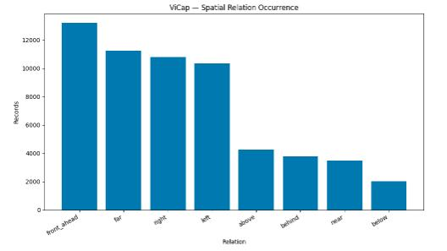
Figure 4
Distribution of spatial-relation keyword occurrences in the 17,198 non-book ViCap records. Each record is counted at most once per relation, and categories may overlap.
As shown in Figure 4, front or ahead is the most frequent relation, appearing in 13,203 records (76.8%). Far, right, and left also occur in more than 60% of the analyzed records, reflecting the emphasis on forward distance and lateral orientation. Below is the least frequent relation at 11.8%. Because the annotations were initially model generated and often use recurring navigation phrases, these values describe the linguistic content of the available labels rather than independently verified spatial ground-truth instances.
4.4. Safety Category Distribution
Safety indicators were identified in the same 17,198 non-book records through lexical matching across the safety, navigation, short-caption, and detailed-caption fields. Each image was counted once per category but could contribute to multiple categories. The resulting counts may therefore include negated or contextually ambiguous mentions.
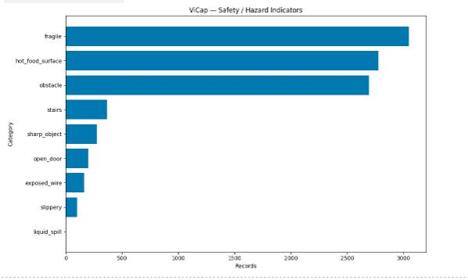
Figure 5
Distribution of safety and hazard keyword occurrences in the 17,198 non-book ViCap records. Categories may overlap, and the separately structured textbook subset is excluded.
As shown in Figure 5, fragile-object indicators form the largest safety category with 3,049 records (17.7%), followed by hot food or surfaces with 2,777 records (16.1%) and obstacles with 2,695 records (15.7%). Stairs, sharp objects, open doors, exposed wires, and slippery surfaces provide additional supervision for safety-aware tasks but remain less frequent. Liquid spills appear only once under the current lexical definition, indicating a clear target for future collection. These statistics strengthen the assistive-vision motivation of ViCap, while human verification remains necessary before treating any safety label as ground truth.
4.5. Annotation Coverage and Verification Status
The final statistics notebook reports complete image and scene identifiers for all 17,198 non-book records. Short and detailed captions are populated for 17,196 records (99.99%). The global coverage values for other fields are lower because the schema is domain specific: the selected VQA field covers 53.80%, object labels 51.23%, food names 35.92%, safety flags 33.03%, navigation captions 29.97%, and OCR text 23.12%. These percentages should not be interpreted as uniform missingness because, for example, food fields apply primarily to restaurant images and navigation captions primarily to street images. The separate 1,237-page textbook export has complete short and detailed captions together with its core curriculum metadata.
Human reviewers compare each record with its source image and can correct scene categories, descriptions, OCR strings, object labels, spatial relations, and task-specific answers. Consequently, future dataset releases should report both the total inventory and the number or proportion of records with completed human verification. This distinction prevents automatically generated but unreviewed records from being interpreted as validated ground truth.
4.6. Preliminary Baseline Feasibility
The model-assisted generation stage provides a preliminary zero-shot baseline for the proposed tasks. Representative vision-language models were able to populate the common schema for street, bus, metro, restaurant, and indoor images. Qualitative examples show that the generated records can identify route numbers, ticket machines, tactile paving, parked motorcycles, menu prices, food components, and relative object locations. They can also produce task-specific answers rather than only generic captions.
The baseline is nevertheless imperfect. Review examples reveal OCR noise, occasional confusion between an object and an obstacle, inconsistent detail levels, and safety statements that require more conservative wording. These observations are consistent with known hallucination risks in large vision-language models (Li et al., 2023b). Consequently, the current results demonstrate schema feasibility and annotation coverage, not final model accuracy.
A formal benchmark should be conducted after the human-verified corpus is frozen and divided into leakage-resistant training, validation, and test sets. Captioning can be evaluated with standard automatic metrics used in Vietnamese captioning studies, such as BLEU, METEOR, ROUGE, and CIDEr, alongside human judgments of correctness, usefulness, and harmful omission (Pham et al., 2024). VQA should report exact or normalized answer accuracy by question type, while safety-oriented outputs should be evaluated separately for false reassurance and missed hazards.
5. Discussion
5.1. Research Contribution
ViCap differs from general Vietnamese captioning datasets in three ways. First, its images are grounded in local access scenarios rather than a single generic visual domain. Second, it treats each image as a source for several related tasks: captioning, OCR-aware understanding, navigation description, safety reasoning, and VQA. Third, it explicitly incorporates human correction after model-assisted generation. This combination can support multi-task training and makes it possible to study whether shared representations improve several forms of assistive output.
The schema also supports different levels of interaction. A user may first request a short description, then ask for details, visible text, obstacles, or route information. The distinction between short and detailed captions is therefore functional rather than stylistic. Similarly, separating raw OCR text from interpreted information allows a system to preserve what is visibly written while giving a contextual answer about its meaning.
5.2. Limitations
The current dataset has several limitations. ViCap is intentionally multi-domain rather than class-balanced, and its present domain sizes are uneven because collection and verification progress differ across domains. The geographic distribution is centered on Ho Chi Minh City, so signs, transit infrastructure, food, and street layouts may not represent other regions of Vietnam. Some scene and safety labels, such as obstructed sidewalks, are also much more frequent than others, while the metro and indoor groups remain under active expansion. Images collected by researchers may differ from images captured directly by people with visual impairments in framing, blur, camera angle, and user intent.
The human-check workflow improves label quality, but the available artifacts do not document independent double annotation or inter-annotator agreement. A single accepted record cannot reveal how often reviewers disagree about detail, safety, or usefulness. Future annotation rounds should assign a stratified subset to at least two reviewers and report agreement for categorical fields, edit distance or semantic similarity for text fields, and adjudication outcomes for safety-sensitive cases.
The term 'safety guidance' must also be interpreted cautiously. A static image cannot guarantee that a path remains clear, estimate all distances reliably, or detect hazards outside the camera view. Models trained with ViCap should present warnings as supplemental information and should not replace orientation-and-mobility training, a cane, a guide dog, or official transit assistance.
5.3. Ethical and Release Considerations
Accessibility datasets can create benefit while also exposing private or copyrighted information. Public images may include bystanders, addresses, phone numbers, license plates, and commercial content. Educational images may reproduce textbook material. Images obtained from websites or social-media pages may also be governed by copyright, creator permissions, and platform-specific terms of service. Before publication, each domain should be assigned a release status: distributable image and annotation, annotation-only with a retrievable identifier, restricted research access, or excluded. Faces and identifiers should be redacted where appropriate, Internet sources should be documented, and all transformations should be recorded.
The dataset should also avoid inferring sensitive characteristics such as disability, ethnicity, age, or socioeconomic status from appearance. Annotators should describe visible content relevant to the task and use neutral language. Records with uncertain text, identity, direction, or safety should explicitly communicate uncertainty. These safeguards are especially important because assistive outputs may be trusted in time-sensitive situations.
5.4. Future Evaluation
Future work will complete human verification for the 22,222-image corpus. Group-based data splits will keep near-duplicate capture sequences and locations within the same split. Baselines should include a compact open vision-language model, a stronger general-purpose model, and task-specific captioning or VQA systems. Evaluation should compare generic prompting, Vietnamese domain prompting, supervised fine-tuning, and multi-task learning.
Beyond automatic metrics, the dataset should be evaluated with Vietnamese users who have visual impairments. A user study can measure whether descriptions answer the intended question, reduce the time needed to locate information, communicate uncertainty appropriately, and avoid distracting detail. Feedback from target users should guide revisions to the annotation schema and the prioritization of future domains.
6. Conclusion
This paper introduced ViCap, a Vietnamese image dataset for assistive vision research. The collection covers educational, transportation, street, indoor, restaurant, and public-service contexts in Vietnam and provides multiple forms of supervision for each image. The labeling pipeline combines low-temperature vision-language generation, structured JSON validation, checkpointed export, duplicate control, and a custom human-review interface that allows every field to be corrected against the source image.
Analysis of the 17,198 non-book records shows that front or ahead is the most frequent spatial relation, while fragile objects, hot food or surfaces, and obstacles are the most frequent safety indicators. The separately analyzed textbook export contributes complete short and detailed captions for 1,237 pages together with subject and bibliographic metadata, representing a structured portion of the 5,024-image book inventory. The current collection is intentionally multi-domain rather than class-balanced, with smaller metro and indoor subsets still under expansion. These findings support the feasibility of the schema but also confirm that lexical occurrence is not equivalent to verified correctness. Human review, privacy screening, copyright review, and user-centered evaluation are essential before public release. Once finalized, ViCap can provide a locally grounded benchmark for Vietnamese image captioning, text-aware VQA, educational image description, obstacle awareness, and accessible multimodal systems.
Acknowledgments
The authors thank the reviewers who inspected and corrected the model-generated annotations and the Faculty of Information Technology, University of Science, Vietnam National University, Ho Chi Minh City, for supporting the data-labeling infrastructure.
References
Bai, S., Chen, K., Liu, X., Wang, J., Ge, W., Song, S., Dang, K., Wang, P., Wang, S., Tang, J., Zhong, H., Zhu, Y., Yang, M., Li, Z., Wan, J., Wang, P., Ding, W., Fu, Z., Xu, Y., Lin, J. (2025). Qwen2.5-VL technical report. arXiv. https://doi.org/10.48550/arXiv.2502.13923
Comanici, G., Bieber, E., Schaekermann, M., Pasupat, I., Sachdeva, N., Dhillon, I., Blistein, M., Ram, O., Zhang, D., Rosen, E., Marris, L., Petulla, S., Gaffney, C., Aharoni, A., Lintz, N., Pais, T. C., Jacobsson, H., Szpektor, I., Jiang, N.-J., ... Helmholz, W. (2025). Gemini 2.5: Pushing the frontier with advanced reasoning, multimodality, long context, and next generation agentic capabilities. arXiv. https://doi.org/10.48550/arXiv.2507.06261
Gebru, T., Morgenstern, J., Vecchione, B., Vaughan, J. W., Wallach, H., Daumé III, H., & Crawford, K. (2021). Datasheets for datasets. Communications of the ACM, 64(12), 86-92. https://doi.org/10.1145/3458723
Gurari, D., Zhao, Y., Zhang, M., & Bhattacharya, N. (2020). Captioning images taken by people who are blind. In A. Vedaldi, H. Bischof, T. Brox, & J.-M. Frahm (Eds.), Computer Vision-ECCV 2020 (pp. 417-434). Springer. https://doi.org/10.1007/978-3-030-58520-4_25
Lam, Q. H., Le, Q. D., Nguyen, K. V., & Nguyen, N. L.-T. (2020). UIT-VIIC: A dataset for the first evaluation on Vietnamese image captioning. In Computational Collective Intelligence: 12th International Conference, ICCCI 2020 (pp. 730-742). Springer. https://doi.org/10.1007/978-3-030-63007-2_57
Li, J., Li, D., Savarese, S., & Hoi, S. (2023a). BLIP-2: Bootstrapping language-image pre-training with frozen image encoders and large language models. In Proceedings of the 40th International Conference on Machine Learning (Vol. 202, pp. 19730-19742). PMLR. https://proceedings.mlr.press/v202/li23q.htmll
Li, Y., Du, Y., Zhou, K., Wang, J., Zhao, X., & Wen, J.-R. (2023b). Evaluating object hallucination in large vision-language models. In Proceedings of the 2023 Conference on Empirical Methods in Natural Language Processing (pp. 292-305). Association for Computational Linguistics. https://doi.org/10.18653/v1/2023.emnlp-main.20
Pham, A.-C., Nguyen, V.-Q., Vuong, T.-H., & Ha, Q.-T. (2024). KTVIC: A Vietnamese image captioning dataset on the life domain. arXiv. https://doi.org/10.48550/arXiv.2401.08100
Tran, K. Q., Nguyen, A. T., Le, A. T.-H., & Nguyen, K. V. (2021). ViVQA: Vietnamese visual question answering. In Proceedings of the 35th Pacific Asia Conference on Language, Information and Computation (pp. 683-691). Association for Computational Linguistics. https://aclanthology.org/2021.paclic-1.72/
World Health Organization. (2019). World report on vision. https://www.who.int/publications/i/item/9789241516570
Bionote
Lan Anh Nguyen Thi is a master's student at the Faculty of Information Technology, University of Science, Vietnam National University, Ho Chi Minh City. My current research concerns Vietnamese vision-language data and assistive artificial intelligence for people with visual impairments.
Hải Minh Nguyễn is affiliated with the Faculty of Information Technology, University of Science, Vietnam National University, Ho Chi Minh City, and is a co-author of the ViCap dataset project.

Appendices
Appendix A: Annotation Field Definitions
Field | Definition
image_name | Stable identifier linking an annotation record to its image.
scene_type | Controlled category describing the main environment or user situation.
caption_short | Concise Vietnamese summary intended for rapid scene understanding.
caption_detail | Longer Vietnamese description of objects, text, spatial relations, and context.
navigation_caption | Orientation-focused description of the path and relative positions.
objects | Comma-separated object labels grounded in the image.
text_raw/text_ocr | Visible text transcribed from signs, displays, menus, or documents.
VQA_* | Domain-specific answers concerning obstacles, safety, location, information, food, utensils, or prices.
safety_flags | Machine-readable warnings for hazards or conditions requiring attention.
Grade/Subject | Curriculum metadata used by the separately maintained textbook subset.
Collection/Title | Book-series and title metadata for educational page images.
notes | Reviewer comments, uncertainty, or exceptional conditions.
Table 4
Core fields recommended for the released dataset
Appendix B: Human Review Checklist
For each record, the reviewer should verify that (a) every mentioned object is visible; (b) OCR text matches the image and preserves Vietnamese diacritics where readable; (c) left, right, ahead, behind, clock-face, and distance expressions are consistent with the camera view; (d) obstacle and safety statements do not imply certainty beyond the image; (e) short and detailed captions serve different information needs; (f) question-answer fields answer the intended domain question; and (g) personal or copyrighted information is flagged for release review.

